CO4 AT 1-CODING CHALLENGE
Name:G.Krishitha
Reg.no:192524451

1. Develop a Dynamic Programming algorithm to find the minimum cost path in a given cost matrix. A traveler starts from the top-left corner of the grid and must reach the bottom-right corner. At each step, the traveler is allowed to move either to the right, downward, or diagonally down-right. Each cell contains a specific cost, and the objective is to determine the path with the minimum total cost
CODE: 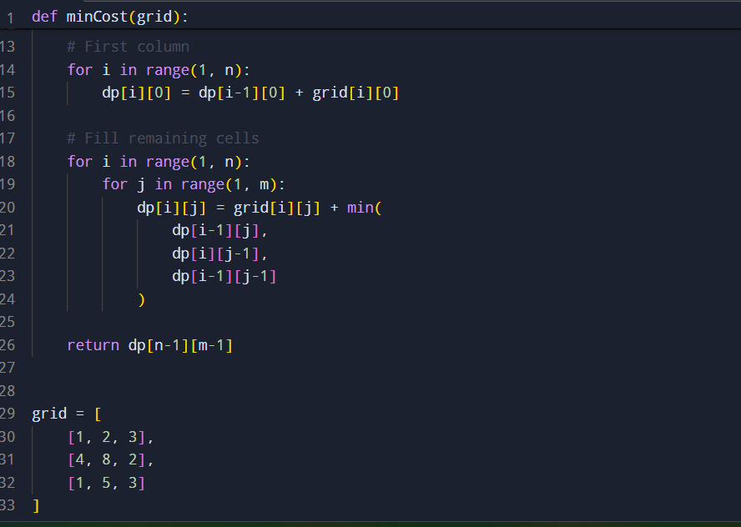

OUTPUT: